

How often should my child train.
There are many considerations here....
- How old is your child?
- How long have they been participating in formal running training sessions?
- Are they involved in other sports?
- If so, how many days of the week are they currently participating in?
- Are you scheduling in active recovery or rest days?
- If not...why not?
- What is the current health status of your child?
- Are they sleeping well? ( 8- 10+ hrs per night).
- Are they in an active growth phase?
- Are they studying for major exams?
- Do they have part time/ casual work?
- What is your childs goals?
- How often do They want to train?
- How often is your child competing in races?
The general rule is to NOT exceed the age of the child in training hours per week.
i.e. 10yrs - no more than 10hrs a week.
The workload I suggest to athletes varies depending on all the above factors...during the course of a season, workloads are adjusted to factor in preparing for major races - to ensure athletes are at the best when needed
Overuse injuries are unfortunately VERY common.
Under preparing for major events can also predispose athletes to injury.
The balancing act of time spent in specific areas of training is why guidance from welk trained coaches is important.
Feedback and communication between athletes, parents and coaches is crucial.
Be honest with your child's coach about how your child is feeling and their health status.
As a coach – my first priority is to ensure that the young people I train are healthy and well.
Then I look to the long term progression of athletes...this means that training programs are designed to assist athletes progressively grow stronger, fitter and faster whilst also adopting a growth mindset and improving their mental and emotional resilience.
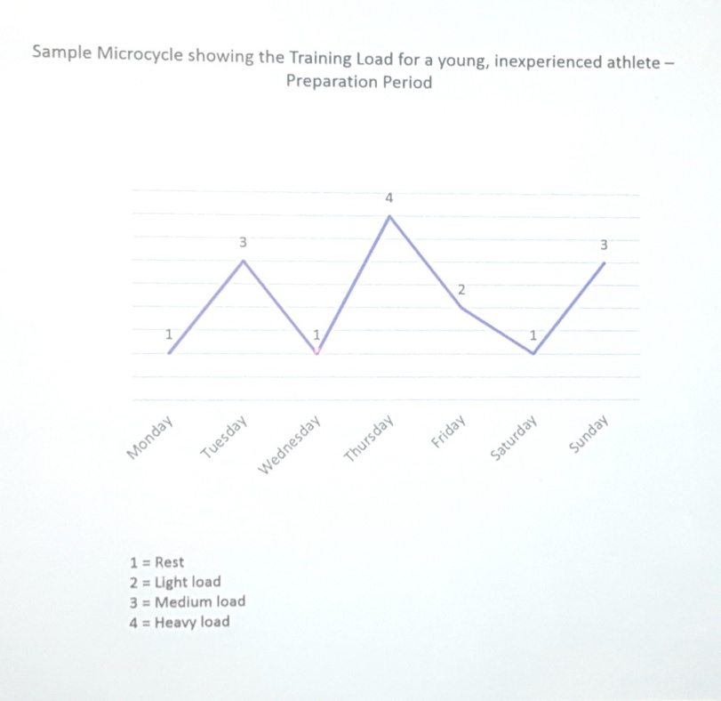
Short term results at the expense of your child's physically, emotional and mental wellbeing ARE NEVER WORTH IT IN THE LONG RUN!
This graph shows a sensible program which allows for active recovery/rest periods over the course of a week.
Failure to implement active recovery/ rest means that optimum adaptation ( improvement as the result of training) does not take place.
Over training and lack of quality recovery, sleep and nutrition will directly affect and athletes ability to improve and perform.

www.limbactiveaustralia.com This information is not to be reproduced without direct permission from LimbActive Australia.

